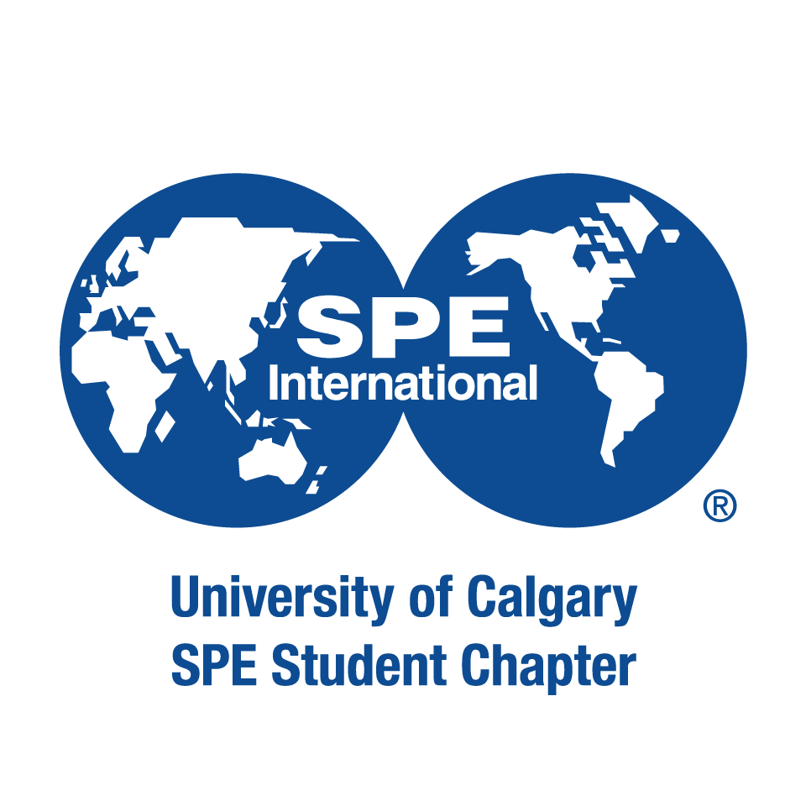

This application form is a requirement for ALL council positions (President, Vice President, Director, and Representative positions). Presidential and senior applicants should consult Page 7 of the Executive Transition Document for additional requirements. All applicants are preferred to be 2021 – 2022 student members of the Petroleum & Energy Society in order to seek a position on council. Note that Presidential applications are due by Friday, March 5th at 11:59pm and all remaining applications by Sunday, March 14th at 11:59pm. Attendance at the PES AGM on Thursday, March 11th from 6:00pm – 7:00pm is mandatory for those seeking council positions unless a valid reason is provided.
Applications for VP Events and VP Communications were extended till July 18th , 11:59pm.
Applicant Information:
First and Last Name:
Faculty of Studies:
Concentration/Discipline:
Current Year of Studies:
Email Address:
Cell Phone Number:

Council Position #1:
Council Position #2:
Extra-Curricular Activities
In 200 words or less, please summarize any extra-curricular activities and past PES involvement (if any), that demonstrate your student initiative and leadership qualities

Goals and Vision
In 200 words or less, please summarize your main reasons for wanting to join the PES council, and any important skills you have that you think will benefit the club in achieving its goals.

Please ensure all sections of the application have been filled out completely and submit via email to the current VP Internal Relations, Mustafa Al Asadi at mustafa.alasadi@ucalgary.ca. The council will review your application, and results will be released soon after the council selection meeting.

Thank you for your application and interest in the Petroleum & Energy Society!

